HUMAN VALUES MAP
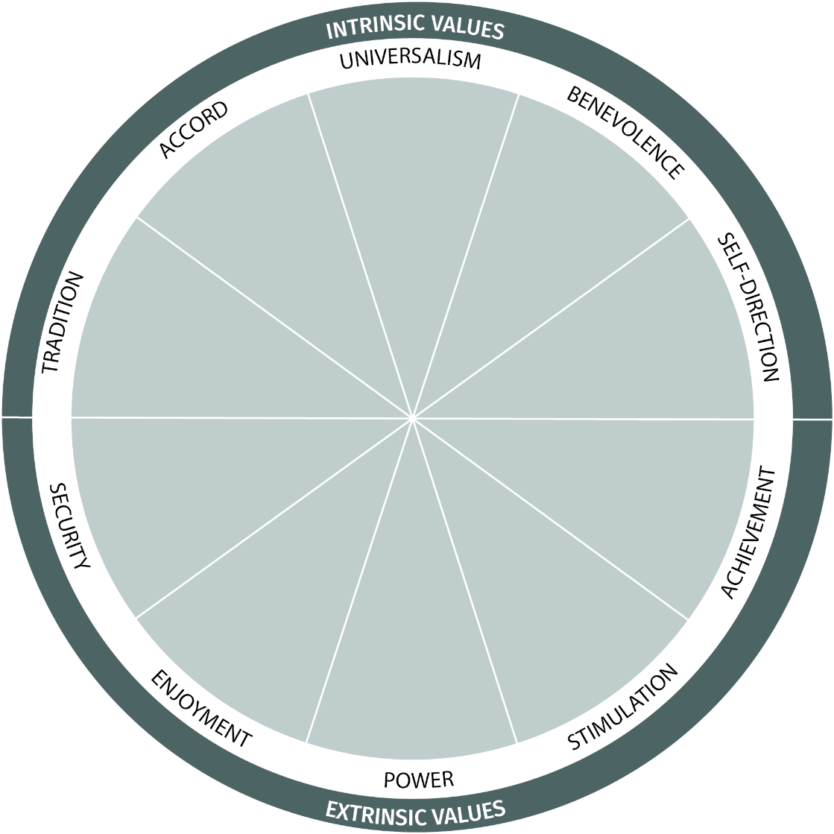
Our core values represent the essence of what we think is most important in life. They inform our attitudes, identity, and behaviour. How much do you know about your core values?

Intrinsic values are deeply fulfilling to pursue.
Extrinsic values create short-term gains and are dependent
on external stimuli, approval or rewards.
Check out the list of values below and select 5-8 that resonate most with you. You’ll find your core values here.
INTRINSIC VALUES
UNIVERSALISM | BENEVOLENCE | ACCORD | TRADITION | SELF-DIRECTION
Connectedness  Beauty  Environmentalism  Fairness  Equality  Inner harmony  Open-mindedness  Peace  Unity with nature  Wisdom | Caring  Forgiveness  Honesty  Friendship  Loyalty  Spirituality  Responsibility  Togetherness  Unconditional love  Service | Duty  Belonging  Honouring elders  Politeness  Reciprocity  Self-discipline | Detachment  Devotion  Humility  Moderation  Religion  Traditions | Curiosity  Freedom  Independence  Privacy  Wellness  Self-respect
EXTRINSIC VALUES
SECURITY | ACHIEVEMENT | STIMULATION | ENJOYMENT | POWER
Immaculateness  Order  Family safety  National security  Patriotism  Safety | Ambition  Intelligence  Success | Adventure  Daring  Excitement | Indulgence  Fun  Pleasure  Stimulation | Influence  Popularity  Prestige  Prosperity  Recognition  Dignity  Strength
VALUES WITHIN TE AO MĀORI
MANAAKITANGA | KOTAHITANGA | KAITIAKITANGA | WHANAUNGATANGA | RANGATIRATANGA
Care, nurturing, respect, generosity, lifting others up | Unity, oneness, togetherness | Guardianship, protection, kinship with the natural world | Kinship with whanau and community, sense of belonging | Self-determination, independence, leadership, empowerment

